Please do not release exams until at least Week 9 of this term, Monday 14th June.
Your Senior High School
Question/Answer Booklet
Name ______________________________
Teacher ___________________

MATHEMATICS 2C
Semester One Exam 2010
Section One:
Calculator-free

Time allowed for this section
Reading time before commencing work: 5 minutes
Working time for this section: 50 minutes

Materials required/recommended for this section

To be provided by the supervisor
This Question/Answer Booklet
Formula Sheet

To be provided by the candidate
Standard items: pens, pencils, pencil sharpener, eraser, correction fluid, ruler,
highlighters
Special items: nil

Important note to candidates
No other items may be used in this section of the examination. It is your responsibility to ensure that you do not have any unauthorised notes or other items of a non-personal nature in the examination room. If you have any unauthorised material with you, hand it to the supervisor before reading any further.

Structure of this paper
Section | Number of questions available | Number of questions to be answered | Suggested working time  (minutes) | Marks available
Section One:  Calculator-free | 5 | 5 | 50 | 40
Section Two:  Calculator-assumed | 10 | 10 | 100 | 80
 |  |  |  | 120

Instructions to candidates
1. Answer the questions according to the following instructions.
Section One: Write answers in this Question/Answer Booklet. All questions should be answered.
Show all your working clearly. Your working should be in sufficient detail to allow your answers to be checked readily and for marks to be awarded for reasoning. Incorrect answers given without supporting reasoning cannot be allocated any marks.
For any question or part question worth more than two marks, valid working or justification is required to receive full marks.
If you repeat an answer to any question, ensure that you cancel the answer you do not wish to have marked.
It is recommended that you do not use pencil except in diagrams.
2. You must be careful to confine your responses to the specific questions asked and to follow any instructions that are specific to a particular question.

MARK ALLOCATION AND RECORDS:
Section | Question | Marks | Awarded |  | Penalties
ONE | 1 | 5
ONE | 2 | 7 |  |  | Rounding (-1)
ONE | 3 | 10
ONE | 4 | 3 |  |  | Units (-1)
ONE | 5 | 15
ONE |  |  |  |  | Notation (-1)
ONE | Penalties | - 1/2/3
 | ONE | 40
 | TWO | 80
 | TOTAL | 120 |  |  | %
Section One (calculator-free) 40 Marks
This section has five (5) questions. Attempt all questions.
Working time: 50 minutes

Question 1 (5 marks)

Consider the Venn diagram on the right consisting of three sets M, N and P.
(a) For each of the following state whether it is true or false.
(i) |M| = 4 _________
M
N
P
U
2 d
4
5 a
b c
3 6 e
7 8
(ii) M ∩ P = {2 , d} _________
(iii) c U _________
(iv) = P _________

(b) Using correct set terminology, state
the relationship between
sets M and N.

__________________

Question 2 (7 marks)
An office contains 11 workers. Some of the workers wear glasses and some of them wear hats to work. The workers at the office are represented below.
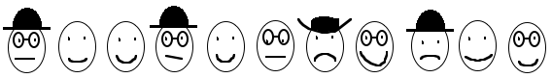
Let G represent the event a worker wears glasses
and H represent the event a worker wears a hat to work.
Describe and then determine the following:
(a) n(G ∪ H). (2 marks)

(b) 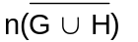 (2 marks)

(c) n(G∩ H). (2 marks)

Question 3 (10 marks)
(a) Expand and simplify each of the following.
(i) −3x(x − 5y) (1 mark)

(ii) (2x + 1)(3 − 2x) (2 marks)

(iii) 4x + 5 − 3(2x + 1) (2 marks)

(b) Evaluate.
(i) −3 + (−2) − 7 (1 mark)

(ii) 3 − 2 × 4² (2 marks)

(iii) 8⁰ − 3 × (−0·1) (2 marks)

Question 4 (3 marks)
A walker is positioned 2 metres to the left of a fixed point. He walks away from this fixed point up a hill so that he is now 26 metres horizontally left of the fixed point and at a vertical height of 45 metres above this fixed point. Assume the hill rises at a constant angle.

(a) Determine the gradient of the hill. (2 marks)

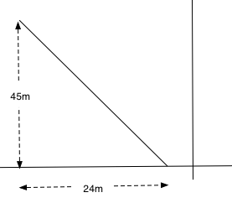

(b) Show how you would calculate how far he has walked. (1 mark)
Question 5 (15 marks)
(a) Solve each of the following.
(i) 3x − 6 = 9 (1 mark)

(ii) (2x + 1)(4 + x) = 0 (2 marks)

(iii) 9 − 25x² = 0 (3 marks)

(iv) x² − x − 12 = 0 (3 marks)

(b) Sketch each of the following on the provided axes. (6 marks)

(i) y = (x + 3)² − 4 | 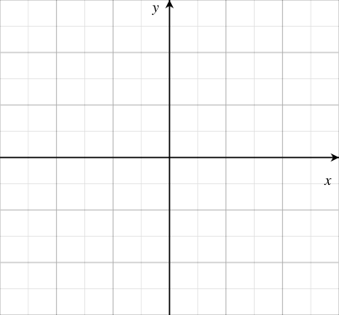
(ii) y = (x − 2)(2x + 1)

Additional working space
SOLUTIONS

Question 1 (5 marks)

Consider the Venn diagram on the right consisting of three sets M, N and P.
(a) For each of the following state whether it is true or false.
(i) |M| = 4 False √
M
N
P
U
2 d
4
5 a
b c
3 6 e
7 8
(ii) M ∩ P = {2 , d} True √
(iii) c U True √
(iv) = P False √

(b) Using correct set terminology, state
the relationship between
sets M and N.

N ⊂ M √

Question 2 (7 marks)
An office contains 11 workers. Some of the workers wear glasses and some of them wear hats to work. The workers at the office are represented below.
Let G represent the event a worker wears glasses
and H represent the event a worker wears a hat to work.
Describe and then determine the following:
(a) n(G ∪ H). (2 marks)
Number of workers who wear glasses or a hat. √
7 √

(b) (2 marks)
Number of workers who do not wear glasses nor a hat. √

4 √
(c) n(G∩ H). (2 marks)
Number of workers who wear a hat but do not wear glasses, √
2 √
Question 3 (10 marks)
(a) Expand and simplify each of the following.
(i) −3x(x − 5y) = −3x² + 15xy √ (1 mark)

(ii) (2x + 1)(3 − 2x) = 6x + 3 − 4x² − 2x √ (2 marks)
= 4x + 3 − 4x² √

(iii) 4x + 5 − 3(2x + 1) = 4x + 5 − 6x −3 √ (2 marks)
= −2x + 2 √

(b) Evaluate.
(i) −3 + (−2) − 7 = −12 √ (1 mark)

(ii) 3 − 2 × 4² = 3 − 32 √ (2 marks)
= −29 √

(iii) 8⁰ − 3 × (−0·1) = 1 − (−0·3) √ (2 marks)
= 1·3 √

Question 4 (3 marks)
A walker is positioned 2 metres to the left of a fixed point. He walks away from this fixed point up a hill so that he is now 26 metres horizontally left of the fixed point and at a vertical height of 45 metres above this fixed point. Assume the hill rises at a constant angle.
(a) Determine the gradient of the hill.
Grad = 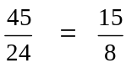 √ √

(b) Show how you would calculate how far he has walked.
d = 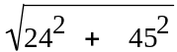 √

Question 5 (15 marks)
(a) Solve each of the following:
(i) 3x − 6 = 9 (1 mark)
x = 5 √

(ii) (2x + 1)(4 + x) = 0 (2 marks)
x = −0·5 √ x = −4 √

(iii) 9 − 25x² = 0 (3 marks)
(3 + 5x)(3 − 5x) = 0 or x² = 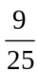 √
x = 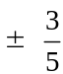 √ √

(iv) x² − x −12 = 0 (3 marks)
(x − 4)(x + 3) = 0 √
x = 4 √ x = −3 √

(b) Sketch each of the following on the provided axes. (6 marks)

(i) y = (x + 3)² − 4  y intercept √  turning point √  shape √ | 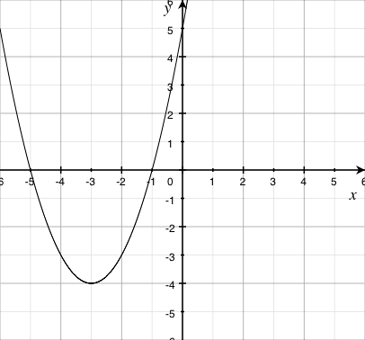
(ii) y = (x − 2)(2x + 1)  x & y intercepts √ √  shape √ | 